Signup of User -
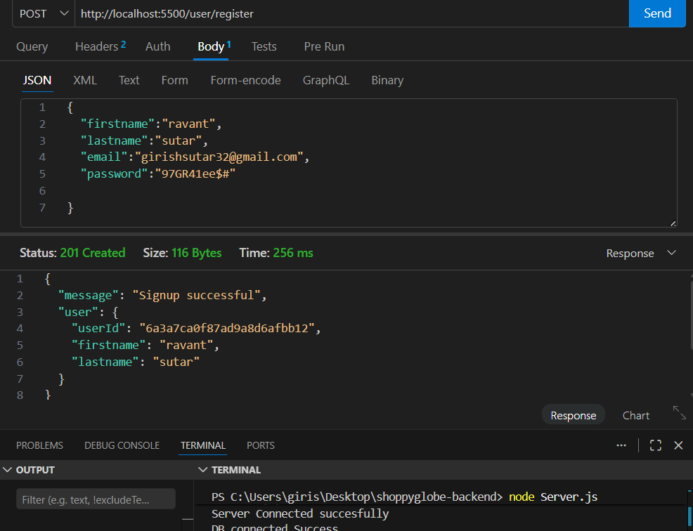

Login –
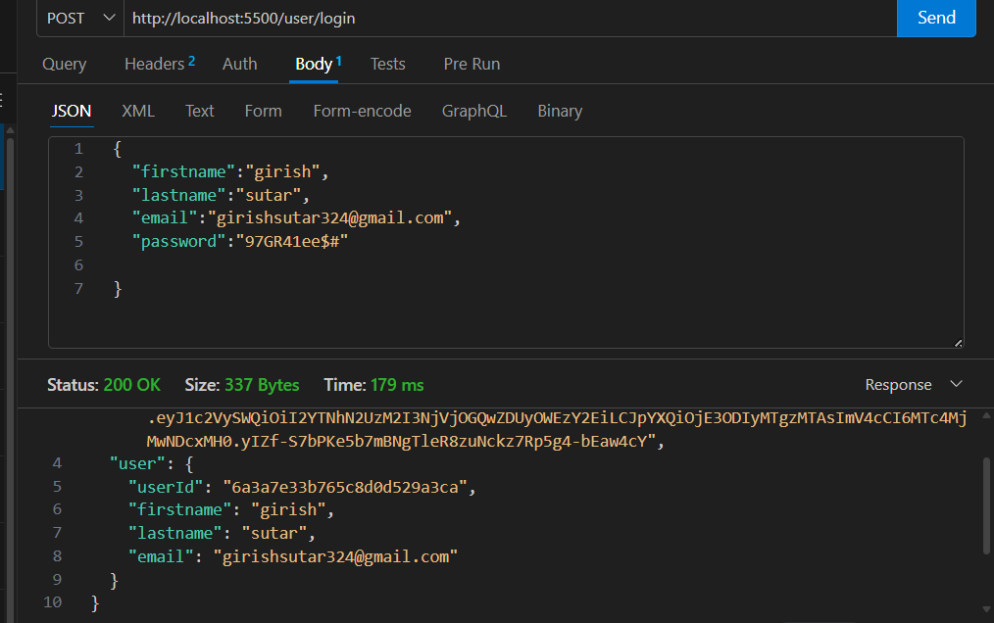

MongoDB DataBase –
Shoppyglobe – Database,
Collection-
1)carts
2)loginmodels
3)products

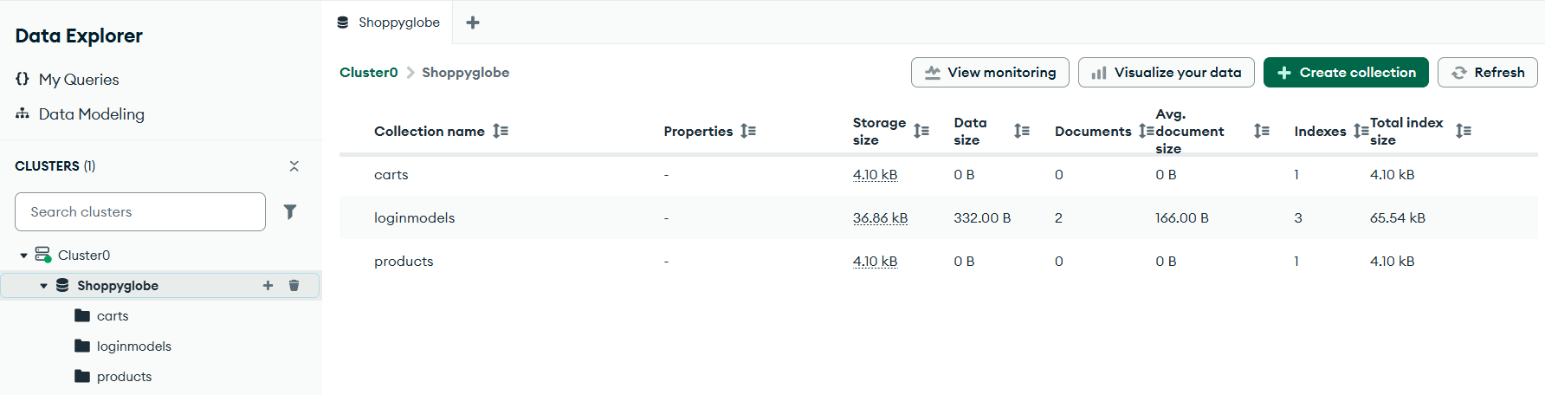

Login Mongodb Database –
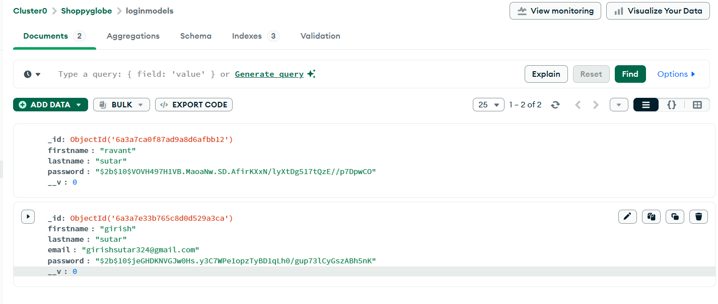

Getting the Product –
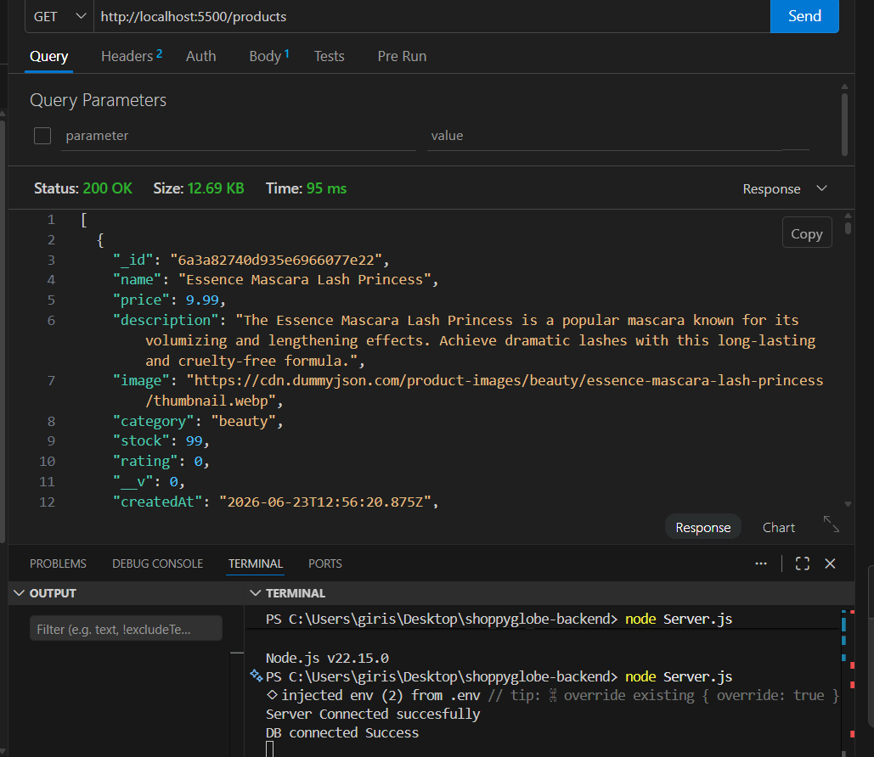

Product Data in MongoDb—
